Name_______________________ WS#
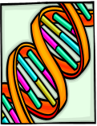
Class____________ Date___________

Should This Dog Be Called Spot?

Imagine this microscopic drama. A sex cell from a male dog joins with a sex cell from a female dog. Each dog’s sex cell carries 39 chromosomes. The fertilized egg that results contains 78 chromosomes. It receives a set of chromosomes from each parent. Suppose that you could look at one pair of the fertilized egg’s chromosomes.

From the female dog:

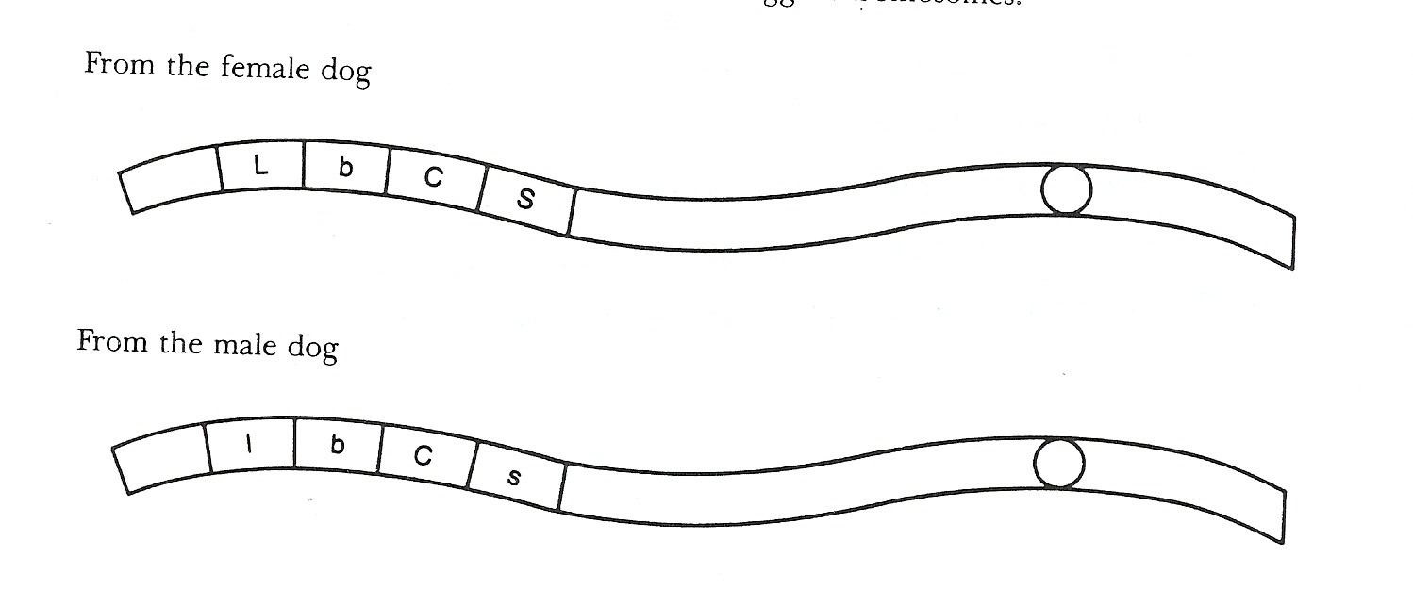
From the male dog:

Each chromosome of the pair contains genes for the same traits. But one chromosome may have a dominant gene and the other a recessive gene. Use the drawing and the chart to answer the questions.

Trait | Dominant Gene | Recessive Gene
Hair length | Long (L) | Short (l)
Hair texture | Bristly (B) | Silky (b)
Hair curliness | Curly (C) | Straight (c)
Coat pattern | Spotted (S) | Solid (s)

1. Would the new puppy have a spotted coat? Explain. Yes, since the female dog has a dominant trait for spots

2. Does the female dog have a spotted coat? Yes

Explain: since the female dog has a dominant trait for having spots she has spots.

3. Does the male dog have a spotted coat? No

Explain: The male dog doesn’t have a dominant trait for spots so he doesn’t has spots.

4. What would the puppy’s hair texture be? Bristly

5. Would the puppy have curly or straight hair? Curly

6. a. Does the female dog have curly hair? Yes

- Does the male dog have curly hair? Yes

7. Would the puppy be a hybrid or a purebred for hair length? Yes



